 | 

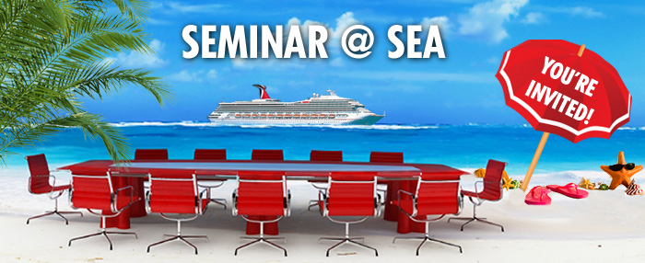
Dear Travel Agent,
We'd like to extend an invitation to you and a guest to join us in 2017 aboard one of our beautiful ships for an exciting Seminar @ Sea.
Our 2017 Seminar @ Sea program includes:

- Special Shore Excursions and pricing
- $50 USD gift card booking incentive
- Casino Coupons
- Discounted Spa
- Cruise Lines International Association (CLIA) credits on all sailings (excluding Carnival Dream sailing on 10/15/17, Carnival Glory, Carnival Magic, Carnival Valor, and the Carnival Sunshine)
- Endless networking opportunities, and more!

Here's a list of available dates and prices: in USD$

2017 Seminar @ Sea Schedule
Ship | Sail Date | Duration | Port | Itinerary | *Interior  Per Person | *Ocean View  Per Person | *Balcony  Per Person
Carnival Triumph | 10/14/2017 | 5 | New Orleans | CZM Plus - Western Caribbean | $264.75 | $289.75 | $339.75
Carnival Dream | 10/15/2017 | 7 | New Orleans | CZM Plus - Ex Western Caribbean | $405.65 | $475.65 | $580.65
Carnival Glory | 11/4/2017 | 7 | Miami | CZM Plus - Ex Western Caribbean | $405.65 | $440.65 | $545.65
Carnival Miracle | 11/4/2017 | 7 | Los Angeles | Mexican Riviera | $440.65 | $475.65 | $545.65
Carnival Valor | 11/13/2017 | 5 | Galveston | CZM Plus - Western Caribbean | $264.75 | $289.75 | $339.75
Carnival Magic | 11/25/2017 | 7 | Port Canaveral | CZM Plus - Ex Western Caribbean | $405.65 | $475.65 | $545.65
Carnival Dream | 11/26/2017 | 7 | New Orleans | Western Caribbean | $405.65 | $440.65 | $510.65
Carnival Liberty | 11/26/2017 | 4 | Port Canaveral | Bahamas | $191.80 | $211.80 | $251.80
Carnival Sunshine | 12/1/2017 | 8 | Port Canaveral | Exotic Eastern Caribbean | $463.60 | $543.60 | $623.60
Carnival Magic | 12/2/2017 | 7 | Port Canaveral | Exotic Eastern Caribbean | $440.65 | $510.65 | $580.65
Carnival Splendor | 12/3/2017 | 7 | Miami | Exotic Eastern Caribbean | $405.65 | $440.65 | $545.65
Carnival Breeze | 12/10/2017 | 7 | Galveston | Western Caribbean | $405.65 | $475.65 | $545.65

While on board, you'll enjoy your own time to explore the ship and also participate in our latest Seminar @ Sea offerings! Seminars include sessions on social media, the brand module, and product information to stay up-to-date on the latest trends and Carnival news.
To top it off, we'll even award 340 credits towards your Carnival Passport just for participating!
To book, call us at 1-866-207-0035 Monday through Friday from 9:00am to 5:30pm ET and ask for any of the above Seminar @ Sea dates. You are encouraged to book soon as these events fill up quickly and are based on availability.
We hope you can join us!
Sincerely,

Adolfo M. Pérez, CTC
Vice President, Sales and Trade Marketing
Carnival Cruise Line



*Terms and Conditions: Cruise rates are in US dollars, per person and based on double occupancy. Offer is capacity controlled. Offer is valid only for certified Carnival Travel Agents participating in the Seminar @ Sea Program. Category restrictions and exclusions apply. Carnival reserves the right to withdraw and/or change offer at any time without prior notice. Cruise Fare does not include Taxes, Fees and Port Expenses. Taxes, Fees and Port Expenses range from $56.90 to $359.73, and are assessed on a per guest basis and according to the itinerary. Travel Agents may select stateroom type (e.g. interior, ocean view or balcony) available, but Carnival assigns the deck and location of the stateroom. Stateroom assignment will be provided at the time of check in on embarkation day. Full per person payment is required at the time of booking. Carnival reserves the right to assess a change fee according to the date of the request, the length of the cruise, and the actual cruise sail date. Full cancellation penalties apply once booked. Travel Agents can only attend one Seminar @ Sea per year. Ships' Registry: The Bahamas, Panama & Malta.
This message was sent from:  Carnival Cruise Line  3655 NW 87 Avenue, Miami, FL 33178-2428 |  | 

Forward this Email to a fellow Travel Partner
To change your email preferences, please click here. View Privacy Policy.
© 2016 Carnival Corporation. All rights reserved. Ships' Registry: The Bahamas, Panama and Malta.

