Mr. Manuel Marrero Cruz Friday, October 15, 2004
Minister of Tourism
Malecon y G
El Vedado
Ciudad de la Habana, Cuba

Dear Mr. Marrero,

We heard from our partners that hotels and resorts in Cuba are selling inventory to Go Travel Direct or one of their subsidiary companies.

As president of the Quebec Regional Council for the Association of Canadian Travel Agencies (ACTA), I thought it would be a good idea to inform you of the situation in Quebec. Go Travel Direct is promoting a distribution model whereby they encourage consumers to bypass the traditional distribution platform represented by the actual travel agencies network. In order to convince the consumers, Go Travel Direct is promoting substantial savings for the consumers if they book directly with Go Travel Direct rather than through a travel agency.

To understand the attitude of Go Travel Direct, you must know that Go Travel Direct is legally operating with a travel agency permit issued by the Quebec Consumer Protection Office. Yet, they advertise in major newspapers, radio, television, in the internet etc. that the consumer does not need a travel agency to book its trip. Needless to say that such an attitude is not very well appreciated by our members.

What we have here, Minister Marrero, is a travel agency undercutting every one else in the industry, a company ready to lose money in order to capture precious market shares, a corporate player that is bringing every one else down in this industry by making all your precious partners in the Quebec market look bad in the eyes of the consumers.

Throughout the years, the Quebec travel agencies in partnership with their suppliers (Vacances Tours Mont-Royal, Vacances Transat, Air Transat, Nolitours Vacances, Caribe Sol, Cubana, Vacance Air Canada, Air Canada, Tours Maison, Sky Service, Vacances Signature) have collectively done an outstanding job in promoting Cuba as the top sun destination in this market.

Each of the members we have heard from has advised that, on its own, it will think twice before selling a destination, hotel or resort that supports the Go Travel Direct model. Each seems to have concluded that if such supplier chooses to support a distribution model that bypasses that member's travel agency, such supplier does not deserve (and may not even expect) the support of the very travel agencies that are being bypassed.

I hope the above information will shed some light on the situation our members are exposed to. Should you wish to contact me I would be more than happy to speak with you.

Sincerely yours,
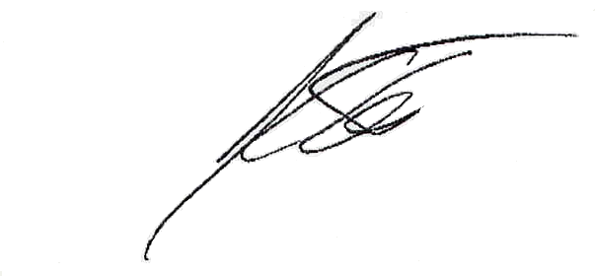

Jean Collette
President, ACTA-Quebec Regional Council

Cc: Yvon Michel, President, Tours Mont-Royal Christiane Théberge, Vice-president Public Affairs, ACTA Allen B. Graham, President, Air Transat Line Chayer, Vice-President, Nolitours Vacances
Line Lemay, Director, Caribe Sol Pina Guercio, Sales Director, Vacances Air Canada
Lina Côté, Sales Director, Tours Maison Manuel Antonio Villa Cruz, President, Cubana Airlines
Rob Giguère, President, Sky Service Lina De Cesare, President, Vacances Air Transat
Guylaine Lavoie, General Sales Manager –Eastern Canada, Air Canada

